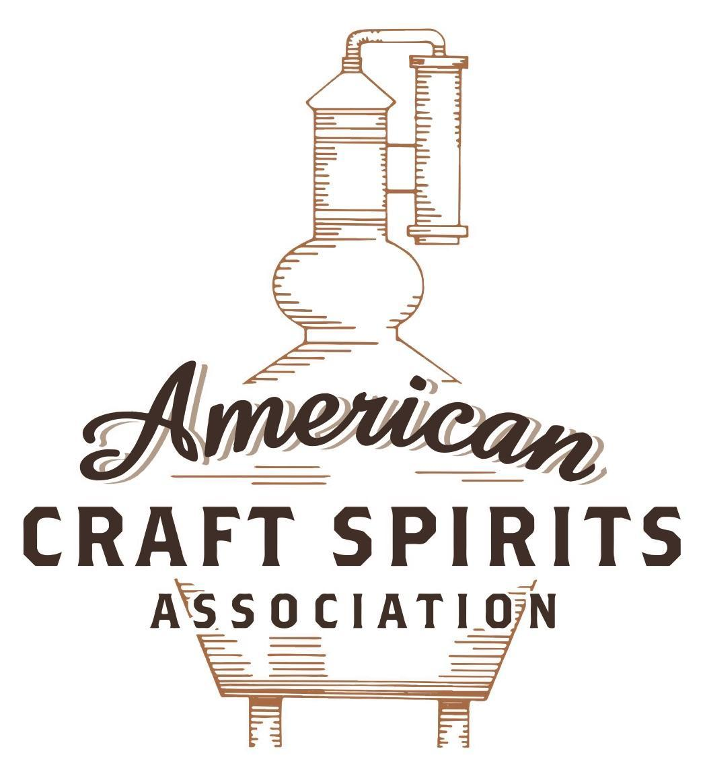
Spirits DtC Shipping Guide

This guide summarizes the direct-to-consumer shipping rules for distilleries in all 50 states and D.C. and also addresses the measures state governments have taken to ease delivery and shipping restrictions during the COVID-19 pandemic.

DtC Quick Guide Comparison

Out-of-State Distilleries  Can Ship Into State? |  |  |  | In-State Distilleries  Can Ship Within State?
State | Yes | No |  | State | Yes | No
AL |  | X |  | AL |  | X
AK | X |  |  | AK | X
AZ | X |  |  | AZ | X
AR |  | X |  | AR |  | X
CA |  | X* |  | CA |  | X*
CO |  | X |  | CO |  | X
CT |  | X* |  | CT |  | X
DE |  | X |  | DE |  | X
DC | X |  |  | DC | X
FL |  | X |  | FL |  | X
GA |  | X |  | GA |  | X
HI |  | X* |  | HI |  | ?*
ID |  | X |  | ID |  | X
IL |  | X* |  | IL |  | X*
IN |  | X |  | IN |  | X
IA |  | X* |  | IA |  | X*
KS |  | X |  | KS |  | X
KY | X |  |  | KY | X
LA |  | X |  | LA |  | X
ME |  | X* |  | ME |  | X*
MD |  | X |  | MD |  | X
MA |  | X |  | MA |  | X
MI |  | X |  | MI |  | X
MN |  | X |  | MN |  | X
MS |  | X |  | MS |  | X
MO |  | X |  | MO |  | X
MT |  | X |  | MT |  | X
NE | X |  |  | NE | X
NV |  | X* |  | NV |  | X
NH | X |  |  | NH |  | X*
NJ |  | X* |  | NJ |  | X*
NM |  | X |  | NM |  | X
NY |  | X* |  | NY |  | X*
NC |  | X |  | NC |  | X
ND | X |  |  | ND | X
OH |  | X |  | OH |  | X
OK |  | X |  | OK |  | X
OR |  | X |  | OR | X
PA |  | X* |  | PA |  | X
RI |  | X* |  | RI |  | X
SC |  | X |  | SC |  | X
SD |  | X |  | SD |  | X
TN |  | X |  | TN |  | X
TX |  | X |  | TX |  | X
UT |  | X |  | UT |  | X
VT |  | X |  | VT |  | X
VA |  | X |  | VA |  | X
WA |  | X* |  | WA | X
WV |  | X* |  | WV |  | X*

WI |  | X |  | WI |  | X
WY |  | X |  | WY |  | X

Notes:
*CA: If passed and signed into law, Senate Bill 620 would allow licensed distilled spirits producers in states other than California and licensed distilled spirits manufacturers or craft distillers in California who obtain distilled spirits direct shipper permits to ship directly to consumers in California
*CT: Consumers with appropriate permit may receive alcohol shipments
*HI: Consumers with appropriate permit may receive alcohol shipments; If passed and signed into law, Senate Bill 65 would allow licensed distilled spirits manufacturers in Hawaii and in states other than Hawaii who obtain direct shipper permits to ship directly to consumers in Hawaii
*IL: If passed and signed into law, Senate Bill 0532 would allow licensed distilled spirits producers in Illinois and in states other than Illinois who obtain distillery shippers’ licenses to ship directly to consumers in Illinois
*IA: If passed and signed into law, House File 639 would allow native distilled spirits manufacturers in Iowa and in states other than Iowa who obtain direct shipper permits to ship directly to consumers in Iowa and to consumers in states other than Iowa
*ME: If passed and signed into law, Legislative Document 1358 would allow distilleries outside of Maine with current manufacturer licenses and distilleries licensed in Maine who obtain spirits direct shipper licenses to ship directly to consumers in Maine
*NJ: (1) If passed and signed into law, Assembly Bill 3167 would allow a craft distillery licensees to ship no more than 9 liters of distilled spirits to a consumer in New Jersey; (2) If passed and signed into law, Senate Bill 3020 would allow craft distillery licensees in New Jersey or in states other than New Jersey to ship no more than 20 liters of distilled spirits to a consumer in New Jersey via common carrier
*NV: Licensed individuals can import one gallon per month of spirits for personal use and the out-of-state supplier must pay excise tax
*NH: If passed and signed into law, Senate Bill 125 would allow licensed liquor manufacturers who obtain direct to consumer shipping permits from the commission to ship directly to consumers in New Hampshire
*NY: Consumer may import up to 90L of liquor per year for personal use without a license; If passed and signed into law, Assembly Bill 3275 would allow licensed liquor manufacturers in states other than New York and licensed distillers and farm distillers in New York to ship no more than thirty-six cases (no more than nine liters per case) of liquor to consumers in New York
*PA: Consumer may place a special liquor order and distiller must ship to a PLCB-operated store
*RI: Distiller can only ship to customer if order was personally placed by customer at distiller's premises
*WA: If passed and signed into law, House Bill 1432 would allow licensed spirits manufacturers in states other than Washington to ship spirits to consumers in Washington
*WV: Distilleries, mini-distilleries, or micro-distilleries licensed in West Virginia or a state other than West Virginia who obtain private direct shipper licenses to ship to a consumer in West Virginia, however the shipments must be made to a retail liquor outlet

MICHIGAN
Shipment Outbound – Silent.
Shipment Inbound – No, all spirits must originally be purchased by and imported into MI by the commission (MCL 436.1203).
Shipment Intra-state – No, distillers and small distillers may sell to consumers at their premises for on or off-premises consumption with the appropriate permits.
COVID-19 Measures – A manufacturer licensee with an approved tasting room permit or license may deliver liquor in a qualified container to a customer using only its own employees.
The following license types may sell alcoholic liquor (beer, wine, mixed spirit drink, or spirits) in original, unopened containers to customers for consumption off the premises:
• Small Distiller license Distiller/Manufacturer of Spirits license
• Any combination of manufacturer licenses with On-Premises Tasting Room Permit:
o Small Distiller license
o Distiller/Manufacturer of Spirits license
o Mixed Spirit Drink Manufacturer license
• Off-Premises Tasting Room license
• Joint Off-Premises Tasting Room license
S.B. 0141, signed and enacted into law on May 26, 2021, allows a qualified retailer that holds a specially designated merchant license to use a common carrier to deliver mixed spirit drinks to a consumer in Michigan. The bill also allows a qualified retailer that holds a specially designated distributor license to use a common carrier to deliver spirits to a consumer in Michigan.
Alcoholic Liquor To Go / For Delivery Link: https://www.michigan.gov/documents/lara/alcohol_to_go_695532_7.pdf
S.B. 0141 Link:
http://www.legislature.mi.gov/documents/2021-2022/publicact/htm/2021-PA-0016.htm
Citation (shipment)
Michigan Compiled Laws
436.1203.amended Sale, delivery, or importation of alcoholic liquor or wine; duties of direct shipper of wine; common carrier; verification that individual accepting delivery is 21 years of age or older; original purchase and importation into state of spirits for sale, use, storage, or distribution; requirements; exceptions; direct shipper license required; application; fee; violation; delivery of beer and wine to home or designated location of consumer; holder of specially designated merchant license; sale or delivery of spirits by qualified small distiller requirements; delivery or sale of beer, wine, mixed spirit drink, or spirits by third party facilitator; reports; retention of books, records, and documents; disclosure; definitions.
(1) Except as provided in this section and section 301, a person shall not sell, deliver, or import alcoholic liquor, including alcoholic liquor for personal use, in this state unless the sale, delivery, or importation is made by the commission, the commission’s authorized agent or distributor, an authorized distribution agent approved by order of the commission, a person licensed by the commission, or by prior written order of the commission.
(7) All spirits for sale, use, storage, or distribution in this state must originally be purchased by and imported into the state by the commission, or by prior written authority of the commission.
Link:
http://www.legislature.mi.gov/(S(arlw5jksppmkdkwdqdd54khh))/mileg.aspx?page=getobject&objectname=mcl-436-1203-amended

436.1534. Small distiller license.
(1) Upon application in a manner acceptable to the commission and payment of the appropriate license fee, the commission shall issue a small distiller license to a person annually manufacturing in this state spirits in an amount not exceeding 60,000 gallons, of all brands combined.
(2) A small distiller may have an approved tasting room and sell at retail in accordance with sections 536 and 537.
(3) This section does not allow the sale of spirits transacted or caused to be transacted by means of any mail order, internet, telephone, computer, device, or other electronic means.
Link: http://www.legislature.mi.gov/(S(ofhfmorkl3a3zqmqnvcpnxjk))/mileg.aspx?page=getObject&objectName=mcl-436-1534

The American Craft Spirits Association (ACSA) is working diligently to give our members and industry partners relevant, current updates on statutes and regulations impacting production, sale and distribution of spirits. With the declaration of the novel coronavirus (COVID-19) in early 2020, many states have issued temporary policy changes or longer-term modernization of alcohol beverage laws. State statutes, regulations created by the state alcohol regulatory authority, as well as any other relevant guidance provided by such authorities (such as advisories, opinions, bulletins, etc.) were reviewed in creation of this document. No city or county ordinances were reviewed. Distillers should be aware that even in states where direct shipping is permissible, always remember to avoid shipping to dry counties. Please consult with your state guild or alcohol beverage authority for the most up-to-date information. This content is intended for educational and informational purposes only. ACSA's pro bono law firm of Malkin Law P.A. provided the core content found in this comprehensive overview of the spirits distribution after COVID-19. It was completed in August 2021 and will be updated regularly. If you have updates you would like to provide, please send to legislation@americancraftspirits.org or directly to the law firm at: ryan@malkin.law / malkin.law. Thank you.

